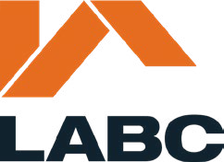

Building Regularisation Certificate Application Form (England)
Building Regularisation Certificate Application
The Building Act 1984, The Building Safety Act 2022, The Building Regulations 2010 (as amended).

1Applicant details
Name
Address (incl postcode)

Phone Email

2Location of site to which the building work relates
Address (incl postcode)

Unauthorised works
3
Description of the unauthorised work

Declaration
4
This application is made in relation to the building work etc., as described above. It is submitted in accordance with Regulation 18 and is accompanied by the appropriate charge.

I / we apply for a Regularisation Certification as described on this form and as detailed on any supplementary documents.

Signature
On behalf of
insert applicants name where the declaration is made by an agent

Date

This form cannot be used for building regularisation certificate applications for higher-risk building work or stage of higher-risk building work or for work to existing higher-risk buildings. Applications for building work to higher- risk buildings can be made here.

