Private Water Drinking Water Safety Plan

for

Supply Name

Please ensure that all consumers of the supply are aware of the contents of this document and where it is kept

Relevant persons
Name | Role and responsibility in relation to the supply | Contact details (email, phone number)
John Smith | Caretaker - John | John.smith@gmail.com  01539123456
Mike Smith | Private Contractor – Treatment Service | Mike.Smith@SmithServicing.com

Diagram/schematic of the private water supply:
Name of Water Supply: …………………………………………………………………………………………………
Draw a diagram/schematic of your private water supply to show the layout and location of the main features
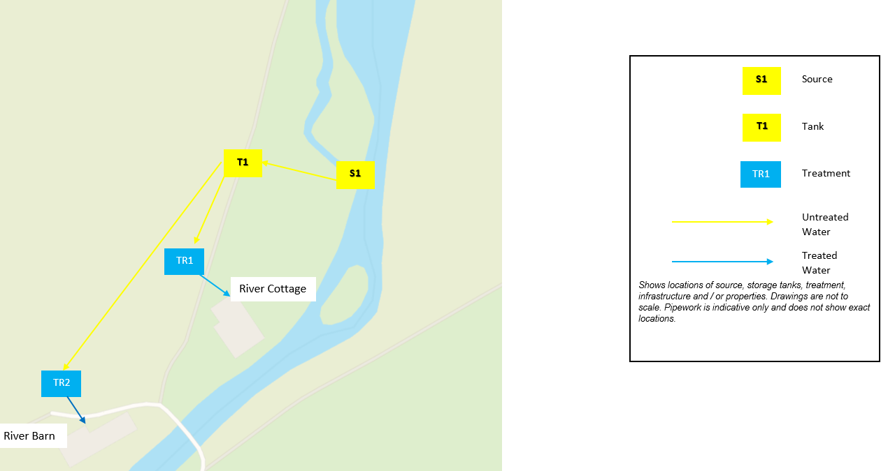
Description of the supply:
Catchment/Source | Storage and distribution | Treatment
Describe  - the general conditions/use of the catchment (e.g. forested, agricultural)  - the source(s) of water and their locations (e.g. borehole, spring, well and grid reference) | Describe  - any water storage, its condition, location and how the water is transported to properties (e.g. water piped from source to 1000L concrete storage tank installed in 1970 at grid ref … and gravity fed to properties).  - the number of people served (separate permanent and temporary population) | Describe  - any treatment (e.g. cartridge filters, chlorination, UV, ion exchange, pH filters) on the supply whether centralised or at individual properties
Properties served by the supply:
Name of resident/owner | Address | Contact details (email, phone number)

Water Supply plan steps:
Catchment/Source
What can go wrong and why? | If the event happens, what hazard(s) might make the water unsafe? | What is the likelihood and severity of this hazard? | What control measures are already in place to combat this hazard? | Monitoring | Action in case control measure is ineffective/damaged?
List what could happen that might introduce hazards to your supply and might make your drinking-water unsafe | - Microorganisms  - Chemicals  - Physical constituents  - Loss of quantity of water | Describe the likelihood and severity of this hazard | List all control measures that are already in place | What monitoring activity will be performed, when and by who? | What action will be taken if the control measures are ineffective or damaged?
Debris in the intake water may build up and block the inlet | Loss of quantity of water / physical constituents | Likelihood- Moderate  Severity – Moderate | Self-cleaning 5mm strainer on inlet | Visual inspection of inlet strainer performed weekly by John Smith | If inlet strainer is missing or damaged then replace with spare.  If inlet strainer is blocked then perform a clean out of debris

Storage/Distribution
What can go wrong and why? | If the event happens, what hazard(s) might make the water unsafe? | What is the likelihood and severity of this hazard? | What control measures are already in place to combat this hazard? | Monitoring | Action in case control measure is ineffective/damaged?
List what could happen that might introduce hazards to your supply and might make your drinking-water unsafe | - Microorganisms  - Chemicals  - Physical constituents  - Loss of quantity of water | Describe the likelihood and severity of this hazard | List all control measures that are already in place | What monitoring activity will be performed, when and by who? | What action will be taken if the control measures are ineffective or damaged?
Faecal matter may enter water storage tank through inspection hatch | Microorganisms | Likelihood – Moderate  Severity - High | Lockable, watertight inspection hatch cover | Visual inspection of hatch cover performed weekly by John Smith | If inspection hatch is missing or damaged then replace with spare  If water tight seal is compromised then reseal with bathroom sealant

Treatment
What can go wrong and why? | If the event happens, what hazard(s) might make the water unsafe? | What is the likelihood and severity of this hazard? | What control measures are already in place to combat this hazard? | Monitoring | Action in case control measure is ineffective/damaged?
List what could happen that might introduce hazards to your supply and might make your drinking-water unsafe. | - Microorganisms  - Chemicals  - Physical constituents  - Loss of quantity of water | Describe the likelihood and severity of this hazard. | List all control measures that are already in place. | What monitoring activity will be performed, when and by who? | What action will be taken if the control measures are ineffective or damaged?
UV bulb may fail | Microorganisms | Likelihood – Moderate  Severity - High | Warning light on outside of treatment room | Visual inspection of UV warning light daily by residents of the farm where treatment located | If UV warning light is on immediately inform users of supply and replace the UV bulb (see standard operating procedures)

Standard Operating Procedure
Task | Frequency | Instructions | Person Responsible
Changing UV Bulb | Every 11 Months | 1) Grab a bucket, a clean cloth, some CLR or a similar cleaning product and the appropriate UV bulb.  2) Turn off the water supply before the UV System and open a tap downstream of the UV unit to release the pressure and then close the tap. Close a valve after the UV to keep the water from flowing backward through the UV.  3) Turn off any power that is feeding the UV System and let the system cool.  4) Unscrew the safety cap and using protective gloves or a clean cloth, remove the UV lamp. Oils in our hands may damage the quartz sleeve and/or bulb.  5) Remove the UV Bulb and quartz sleeve from the chamber by unscrewing the sleeve bolt.  6) Clean the quartz sleeve using CLR or a similar product to make sure that there are no stains or discolorations. The quartz sleeve is very fragile and can easily break so be careful. If the quartz sleeve has not been replaced in a few years and is not cleaning up well then replace with a new sleeve.  7) Insert the quartz sleeve into the assembly, replace the O-rings and screw the sleeve bolt back on until they are hand tight.  8) Install the new UV bulb into the assembly and be careful not to overtighten the lamp as it is also fragile.  9) Plug in UV power supply. Make sure that you can see that the lamp is lit. You will see a faint blue glow from the ceramic end of the bulb.  10) Slowly refill system by opening the valve ahead of the UV and check for leaks. Slowly open the valve after UV. Once fully pressurized, you can fully open the valves before and after the UV system.  11) Run the water through to remove any non-disinfected water or air bubbles. | John Smith / Mike Smith (Contractor)

Record of monitoring/maintenance
Catchment/Source
Date | Monitoring/maintenance performed | Comments | Performed by | Next Required
28/09/21 | 5mm inlet strainer inspected | Strainer was clear of debris | John Smith |  | 05/10/21

Storage/Distribution
Date | Monitoring/maintenance performed | Comments | Performed by | Next Required
28/09/21 | Visual inspection of storage tank hatch | Hatch is in good condition | John Smith | 05/10/21
Treatment
Date | Monitoring/maintenance performed | Comments | Performed by | Next Required
28/09/21 | UV bulb and quartz sleeve replaced |  | Mike Smith | 28/08/22

Emergency response plan:
Possible emergency situations  e.g. supply runs out, supply contaminated | Steps to be taken to protect public health  e.g. seek/connect alternative supply, boil water before consumption | Person/s to be notified  e.g. other users of the supply, local authority, environment agency | How will you notify the consumers of the supply  e.g. door to door visit, phone calls, signs on taps | What alternative water supply will be provided?  e.g. bottled water supply, contact named emergency water supplier
Supply runs out | Seek alternative water supply – Bottled water | Notify all other users of the supply | Call all residents on the list of properties served by the supply | 10L of bottled water to be ordered per person for next day delivery

South Lakeland District Council Contact Details
Contact: Public Protection Group (Private Water Team)
Email: privatewater@southlakeland.gov.uk
Telephone: 01539 733 333
Address: South Lakeland House, Lowther Street, Kendal, Cumbria, LA9 4DQ

Further information about private water supplies can be found on our website: https://www.southlakeland.gov.uk/your-environment/private-water-supplies/

