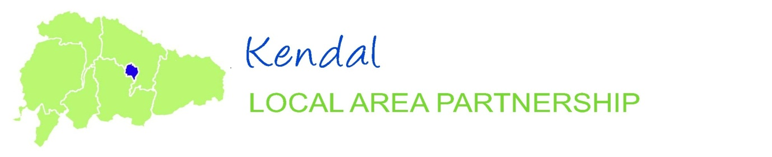
Profile 2013
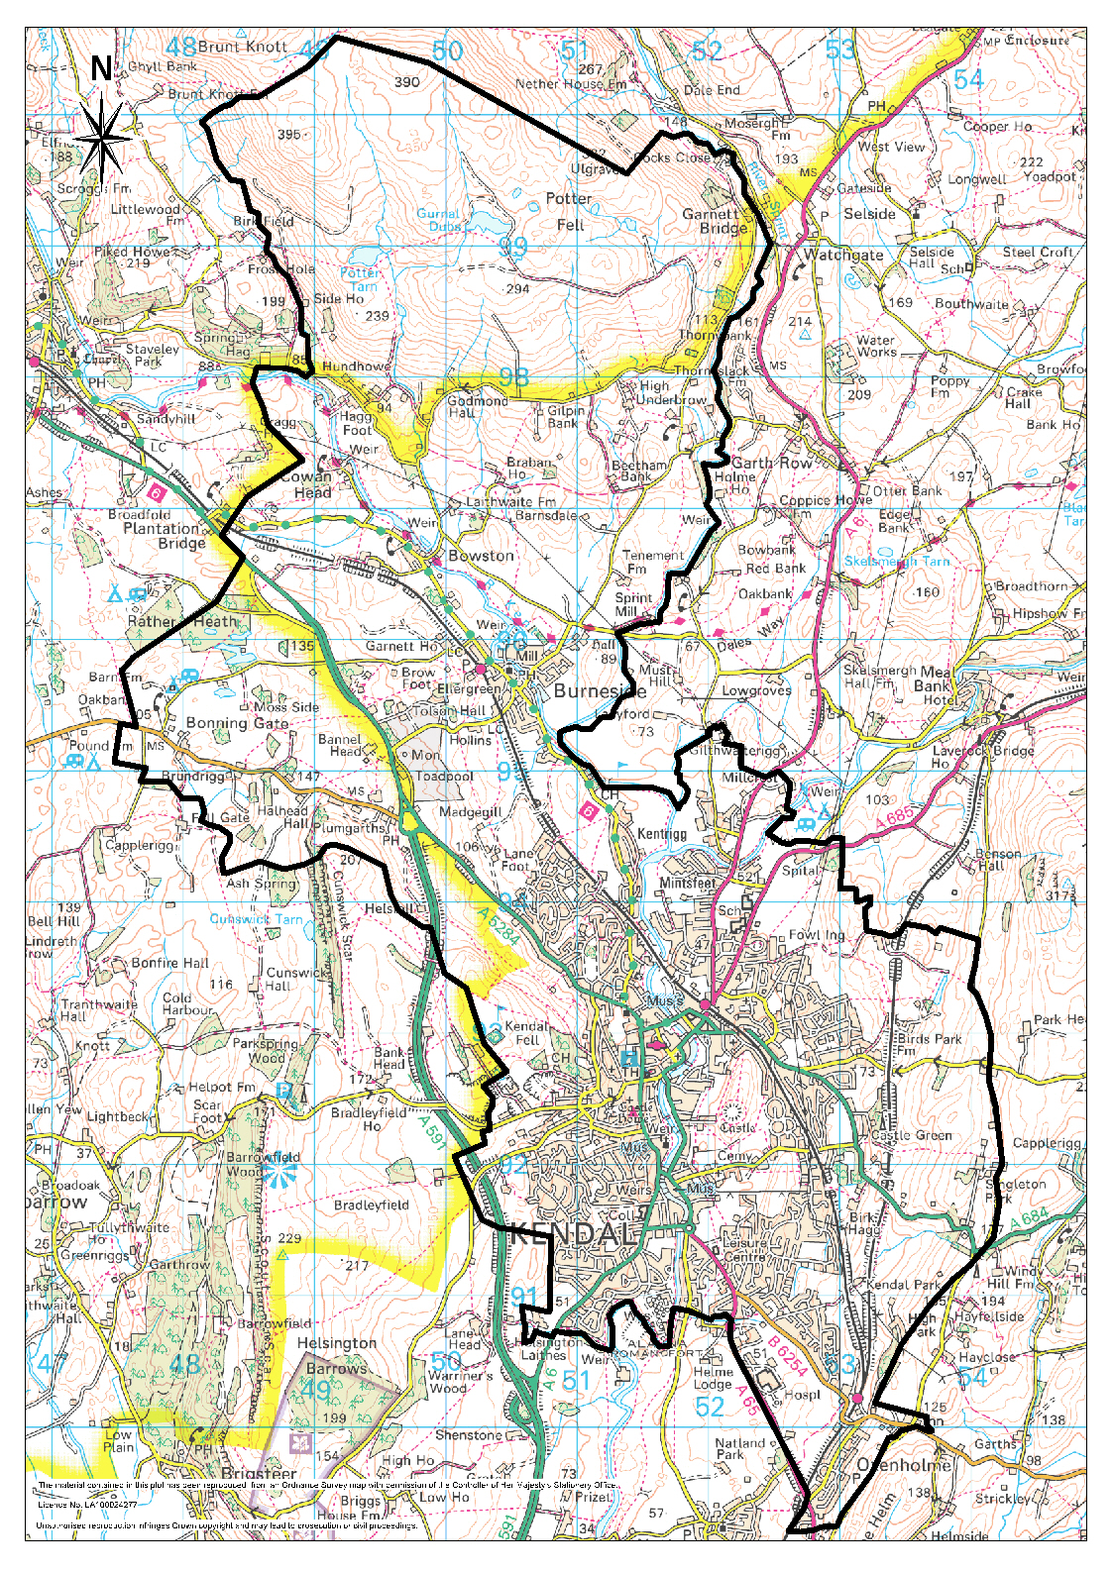
About this profile

The aim of this profile is to provide the Local Area Partnership with background data and intelligence about the characteristics of the area. In this way the partnership can better assess how it needs to focus its efforts.

The majority of the data used in the profile is Census 2011 data. This was collected in March 2011, and gives the most accurate and up-to-date picture of the area possible.

Whilst every effort has been made to provide accurate data, some figures are estimates due to complications with disaggregation.

Table of Contents

Kendal Local Area Partnership in Perspective 3
Kendal LAP – Ward Map 4
Kendal LAP People 5
Usual Resident Population 5
Health & Wellbeing 7
Ethnicity, Nationality & Religion 7
Housing 8
Qualifications 9
Employment & Business Environment 10
Concluding Overview of Kendal LAP 13

Contacts:
Produced by: Policy and Partnerships, South Lakeland District Council, South Lakeland House, Lowther Street, Kendal, Cumbria, LA9 4DQ
policy@southlakeland.gov.uk

Kendal Local Area Partnership in Perspective

Kendal Local Area Partnership (LAP) has the highest population of all the eight South Lakeland LAPs. The LAP incorporates 1 Town Council and 2 Parishes, 15 District Council wards and 5 County Council wards.

The following parishes make up the LAP;

Kendal Town
Burneside

The following District Council wards make up the Partnership;

Kendal Castle
Kendal Far Cross
Kendal Fell
Kendal Heron Hill
Kendal Highgate
Kendal Kirkland
Kendal Mintsfeet
Kendal Nether
Kendal Oxenholme & Natland (only Oxenholme part of ward in LAP area)
Kendal Parks
Kendal Romney
Kendal Stonecross
Kendal Strickland
Kendal Underley
Burneside (only Burneside parish area)

Kendal LAP is fed by the A65 from North Yorkshire to the south, the A590 from Barrow and Ulverston to the west, the A591 from Windermere and the Lakes to the northwest, the A684 from Sedbergh to the east, and the A685 from Shap to the north. The M6 motorway is some 6 miles away to the southeast, providing easy access to the North and Scotland, and the South. Oxenholme station is on the West Coast Mainline, linking Kendal LAP with the rest England and Scotland.

Kendal has a multitude of historical buildings, including the parish church on the riverside in Kirkland, Kendal Castle, the 14th Century Castle Dairy and a host of churches and chapels. Kendal is South Lakeland’s largest town and one of the main centres for shops, employment and services.

The LAP has requested that, where necessary, the profile be broken down into wards. As the map on the following page shows, only the Oxenholme part of Oxenholme & Natland ward is in the LAP. In this instance, only data for Oxenholme will be used. This is also the case with Burneside ward (Burneside parish data will be used).

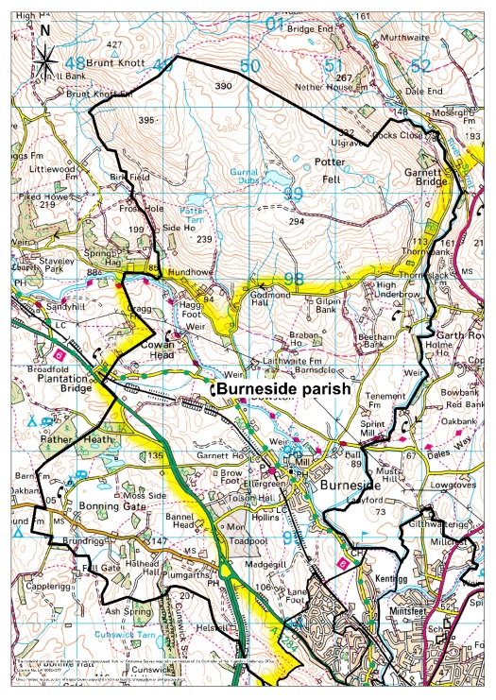
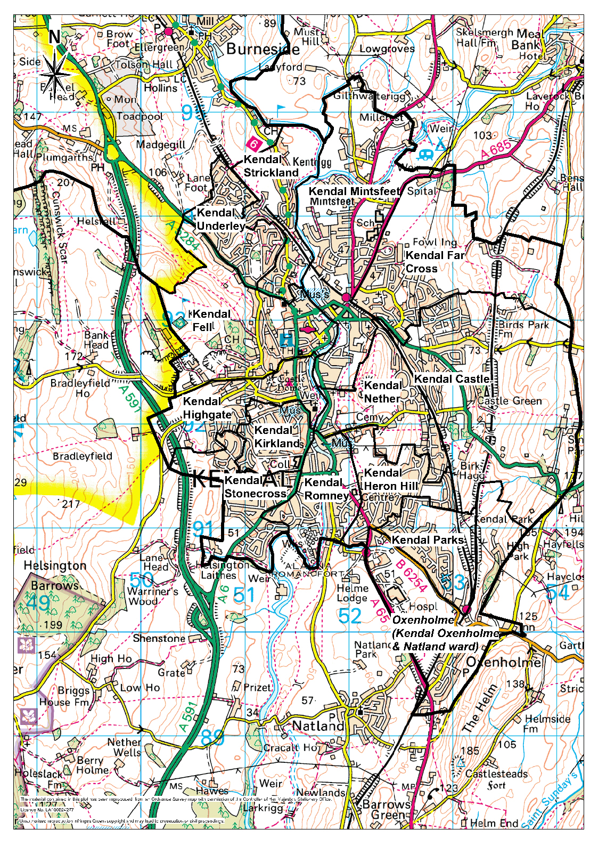
Kendal LAP – Ward Map

Kendal LAP People

Kendal LAP is made up of a number of close knit communities. The people who live in these communities in the main own their own homes, drive their own cars and hold down responsible jobs. People who live in the partnership area are practical and enterprising in their orientation. Many live in what were once council estates but where tenants have exercised their right to buy. They provide a reliable source of labour to local employers and are streetwise consumers. (Source: Mosaic Demographic Profiling)

Usual Resident Population

In 2011, the population of Kendal LAP was 30,171, the largest of all South Lakeland LAPs and 29.1% of the overall population. The population has increased in the LAP area by 3.6% since 2001, where the count stood at 29,133 residents. Kendal Fell ward has seen the biggest proportionate increase in population of 41.7% from 1,664 to 2,358. Kendal Heron Hill ward and Kendal Strickland ward have both seen the biggest decrease of 5.1%.

Male residents make up 48.6% of the population, 51.4% being female. The Kendal LAP covers an area of 3,577 hectares (13.8 square miles), equating to a population density of 8.4 people per hectare (2,186.3 per square mile).

When looking at the broad age bands, the proportion of 0-15 year olds has reduced over the ten year period between 2001 and 2011 (a fall of 6.7%). Kendal Strickland ward saw the biggest proportionate increase in this age group of 27.3%, with Kendal Mintsfeet ward seeing the biggest decrease of 26.7%. There has been an increase of 3.5% in the proportion of 16-64 year olds (working age) since 2001 (a 15.7% increase since 2008). Kendal Fell ward has seen the biggest proportionate increase since 2001 of 45.4%, with Kendal Heron Hill ward seeing the biggest decrease of 13.1%. The over 65 age range has increased by 14.8% since 2001; however, there has been a proportionate decrease since 2008. Kendal Fell ward has seen the biggest proportionate increase since 2001 of 58.9%, while Kendal Kirkland ward has seen the biggest decrease of 17.5%.

When comparing the broad age range proportions (2011) against those at district level, it can be seen that the 0-15 and 16-64 year old age ranges both higher, while the over 65 age range is lower when compared to South Lakeland as a whole.

The Census 2011 data shows us that all the age ranges under the age of 16 have seen a decrease between 2001 and 2011 in the Kendal LAP (a combined reduction of 6.7%). The 60-64 and over 90 age ranges have seen the biggest increases over the ten year period (45.1% and 47.4% respectively). It is also worth noting that all the age ranges over 45 have increased in the LAP since 2001.

29.2% of residents over the age of 16 in Kendal LAP are single. Half (50.2%) are either married or in a civil partnership. 12.5% are either separated or divorced, while 8.1% are widowed.

Health & Wellbeing

The overall health of Kendal LAP’s residents is generally good, with more than four in five (82.2%) saying that their health is either very good or good when asked in the 2011 Census. Just 4.8% (1,436 residents) said that it was either bad or very bad. Oxenholme has the highest proportion of residents with good/very good health (88.3%), while Kendal Highgate and Kendal Nether wards both had the highest proportions of residents with bad/very bad health (6.4%).

Again, the overall majority of residents (82.3%) are not limited in their day-to-day activities by any health problems or disability. However, 2,902 (9.6%) residents’ day-to-day activities are limited a little, and 2,433 (8.1%) limited a lot through health problems or disability. Again, Oxenholme has the greatest proportion of residents with no limiting health problems/disabilities (88.1%). Kendal Heron Hill ward has the biggest proportion limited a little (12%) and Kendal Kirkland the largest percentage limited a lot (10.5%). 10.8% of residents provide some kind of unpaid care, the majority between 1 to 19 hours per week. All of these proportions are similar to those of South Lakeland as a whole.

The average life expectancy in Kendal LAP is 80 years. This is the same as the district as a whole.

An estimated 24% of adults in Kendal LAP smoke, higher than the district estimate of 22%. 21% are estimated to binge drink (consumption of more than 8 units in a day at least once a week for a man, 6 for a woman), slightly higher than the district estimate. It is estimated that one in four Kendal LAP residents are obese, again higher than the South Lakeland estimate.

Adult Lifestyles | Kendal LAP | South Lakeland
Estimate of Smoking | 24% | 22%
Estimate of Binge Drinking | 21% | 20%
Estimate of Obesity | 25% | 22%

8.8% of the children (0-19 years old) in Kendal LAP are said to be living in child poverty. This is defined as children living in families in receipt of Council Tax Credits whose reported income is less than 60% of the average income, or in receipt of Income Support or income based JSA. This is slightly higher than the average for South Lakeland which stands at 7.5%. Kendal Underley ward has the highest proportion of child poverty in the LAP (22.1%). The figure is also high in Kendal Kirkland ward (19.8%).

Ethnicity, Nationality & Religion

The vast majority of Kendal LAP residents are classed as White British (95.7%), with 2.6% being classed as White Other (Irish, European, Australian, Gypsy/Traveller etc). The remaining 1.7% is made up of Asian and Black African/Caribbean residents (including mixed race). All the proportions of the different ethnic groups are similar in comparison to South Lakeland as a whole.

England is the country of birth of 92.1% of Kendal LAP residents, with Britain as a whole accounting for 95.5% (Inc. Scotland, Wales, N. Ireland). 1.9% of residents name their country of birth as other EU member countries, with the remaining 2.6% being born elsewhere. Again, the proportions are similar to South Lakeland as a whole.

Christianity is the main religion in Kendal LAP, as it is in South Lakeland as a whole, with 66.4% of residents following this faith. One in four residents (25.4%) do not follow any religion.

Housing

There are 14,190 dwellings in Kendal LAP (13,557 households, there may be multiple dwellings in one household i.e. shared houses). The majority of the dwellings in Kendal LAP are semi-detached (33.1%) and terraced (28.8%). 19% are detached properties, while 14.1% are purpose built flats and 3.5% are shared houses. When compared to South Lakeland as a whole, the proportions of semi-detached properties, terraced properties, and purpose built flats are all higher, while the proportion of detached dwellings and shared houses are lower in comparison.

Of the total households in Kendal LAP (13,557), 39.7% are owned outright, while 33.1% are owned with a mortgage. 13.9% are private rented (landlord, letting agency etc) and 4.4% are social rented (local authority, housing agency etc). Compared to South Lakeland as a whole, the proportion of properties owned with a mortgage and social rented are higher, while the proportions owned outright and private rented are lower.

In April 2010 there were 321 second homes registered for council tax in the LAP, which is 2.3% of the domestic properties registered for council tax in the LAP area. This is lower than the proportion at district level (6.8%). At the same period there were just 12 holiday homes, 0.1% of the total and again lower than the proportion for South Lakeland overall (2.6%). When compared to the other eight district LAPs, the proportions of second and holiday homes in LAP area is far lower than most (similar to Low Furness & Ulverston LAP).

The average house price in Kendal LAP is £189,172, while the average household income is £31,924. This makes the average house price more almost 6 times higher than the average household income. This is called the household affordability ratio. As can be seen in the following table, the LAP's affordability ratio is lower than the district ratio, showing that properties in Kendal LAP are more affordable than they are in South Lakeland overall (the second most affordable of all eight LAPs).

 | House Price | Household Income | Affordability Ratio
Kendal LAP | £189,172 | £31,924 | 5.9
South Lakeland | £264,385 | £33,199 | 8.0

32.4% of households in Kendal LAP are inhabited by families, 29.3% are inhabited by cohabiting and married couples, and 33.6% are one person households. When compared to South Lakeland as a whole, there is a higher proportion of family households, and lower proportions of couples and one person households.

One in four households (20.8%) in Kendal LAP do not own a car or van, compared to 15.3% at district level. This is likely to be down to the urban nature of most of the LAP, where a vehicle may not be vital to mobility. 73.2% own one or two vehicles.

Nearly all households in Kendal LAP (96.2%) have central heating, with gas (81.2%) being the preferred means of supply. However, 15.5% of households are considered to be in fuel poverty. A household is considered to be in fuel poverty if it needs to spend more than 10% of income on fuel to maintain an adequate heating regime. This proportion is lower than that of South Lakeland, which stands at 23.2%. Burneside parish has the highest proportion of households in fuel poverty, with one in five (21.6%) households considered to be fuel poor.

Qualifications

29.1% of residents aged over 16 years old in Kendal LAP are qualified up to and above level 4 (Masters, Degree, Diploma, Certificate of Higher Education etc). 12.5% are educated up to level 3 (A/AS level), 16.2% up to level 2 (GCSEs at grades A*-C), and 13.1% up to level 1 (GCSEs at grades D-G). 4.2% are qualified as an apprentice, while 21% have no formal qualifications. When compared to South Lakeland as a whole, there are lower proportions of residents qualified up to and above level 4 and residents with no qualifications, and slightly higher proportions of residents qualified up to levels 1, 2, and 3.

Employment & Business Environment

Residents between the ages of 16 and 74 are considered to be of working age in the 2011 Census, and are referred to as the working age population (this has increased from 16-64 years old in the previous 2001 Census).

In 2011 there were 22,064 residents of working age in Kendal LAP. 74.3% of these residents are classed as ‘Economically Active’. This is defined as residents either in employment or actively seeking employment. 40.8% of the working age population were in full-time employment, 17.9% were in part-time employment, and 10.4% were self-employed. 2.2% were unemployed and 3% were full-time students. In comparison with South Lakeland, there are higher proportions of both full-time and part-time employees, and a lower proportion of self-employed residents. Kendal Parks ward has the highest proportion of economically active residents (78.7%), with Heron Hill ward having the lowest (70.1%).

Economically Active

25.7% of the working age population in Kendal LAP are classed as ‘Economically Inactive’. This is defined as residents not in employment or actively seeking employment. 16.9% were retired, 2.3% were students, 2.2% were looking after the home and/or family, and 3.1% were long-term sick or disabled. When compared to South Lakeland as a whole, the LAP has lower proportion of retired residents (of working age). Kendal Heron Hill ward has the highest proportion of economically inactive residents (29.9%), while Kendal Parks ward has the lowest (21.3%).

Economically Inactive

The top five industries of employment in Kendal LAP are; Wholesale, Retail & Vehicle Repair (22%), Human Health & Social Work (12.5%), Manufacturing (9.9%), Education (9.8%), and Construction (8.8%). All these sectors, apart from construction, are also in the top five industries of employment in South Lakeland as a whole.

When looking at the occupations of the working age residents of Kendal LAP, the top three are Professional (14.5%), Skilled Trades (13.8%), and Elementary Occupations (13%). When compared to South Lakeland, there are a larger proportion of residents in Elementary occupations in the LAP, while the other two are also in the top three in the district as a whole.

There are a number of business enterprises situated in the Kendal LAP area. The following table shows the ten largest businesses situated in the LAP in order of the rate of Non-Domestic Rate each business pays.

Business | Type of Business | Ward | Location
ASDA | Supermarket | Kendal Oxenholme & Natland | Burton Road, Kendal
Westmorland General Hospital | Hospital | Kendal Oxenholme & Natland | Burton Road, Kendal
Morrisons | Supermarket | Kendal Mintsfeet | Queen Katherine’s Avenue, Kendal
James Cropper Speciality Papers Ltd | Paper Mill | Burneside | Burneside Mills, Burneside
Booths | Supermarket | Kendal Fell | Wainwrights Yard, Kendal
Lakeland Ltd | Household Accessory Distribution Warehouse | Kendal Mintsfeet | Westmorland Business Park, Kendal
Marks & Spencer | Supermarket | Kendal Fell | Library Road, Kendal
Farley Health Products Ltd | Heinz Food Products Factory | Kendal Mintsfeet | Mint Bridge Road, Kendal
Castle Green Hotel | Hotel | Kendal Castle | Castle Green Road, Kendal
B&Q | DIY Superstore | Kendal Oxenholme & Natland | Burton Road, Kendal

Concluding Overview of Kendal LAP
- In March 2011, the population of Kendal LAP was 30,171, the highest of all South Lakeland LAPs. There has been a 3.6% increase in population since 2001.
- 63.1% of the residents are aged 16-64 years of age (working age), 19.7% are aged over 65 and 17.2% are aged between 0-15 years of age.
- All the age ranges under 16 have seen a decrease between 2001 and 2011 (6.7%), while the over 65 and over 90 age ranges have seen increases of 45.1% and 47% respectively.
- The overall health of Kendal LAP residents is generally good, with just 4.8% saying that their health is bad/very bad. 82.3% of residents are not limited in their day-to-day activities by any health problems or disability.
- The vast majority of residents are classed as White British (95.7%). Christianity is the main religion in the LAP (66.4% following this faith). 25.4% of residents do not follow any religion.
- 72.8% of the 13,557 households in the LAP are either owned outright or with a mortgage. In April 2010 there were 321 second homes and just 12 holiday homes registered for council tax in the LAP area.
- The average house price in Kendal LAP is £189,172, while the average household income is £31,924.
- 15.5% of households in Kendal LAP are considered to be in fuel poverty.
- 29.1% of residents are qualified up to or above level 4 (Degree, Diploma etc), while 12.5% are educated up to level 3 (A/AS level). 21% have no formal qualifications.
- 74.3% of the working age population are ‘Economically Active’. 40.8% are full-time employed, 17.9% part-time, and 10.4% self-employed. 2.2% are unemployed. 25.7% are ‘Economically Inactive’, with the majority (16.9% of the working age population) being retired.
- The top five industries of employment in Kendal LAP are; Wholesale, Retail & Vehicle Repair, Human Health & Social Work, Manufacturing, Education, and Construction.
- The top three occupations in the LAP are Professional, Skilled Trades and Elementary.

The following link to the Office for National Statistics website can be used to view various types of data and statistics at different geographical levels including district, ward and parish level. http://www.neighbourhood.statistics.gov.uk/dissemination/

