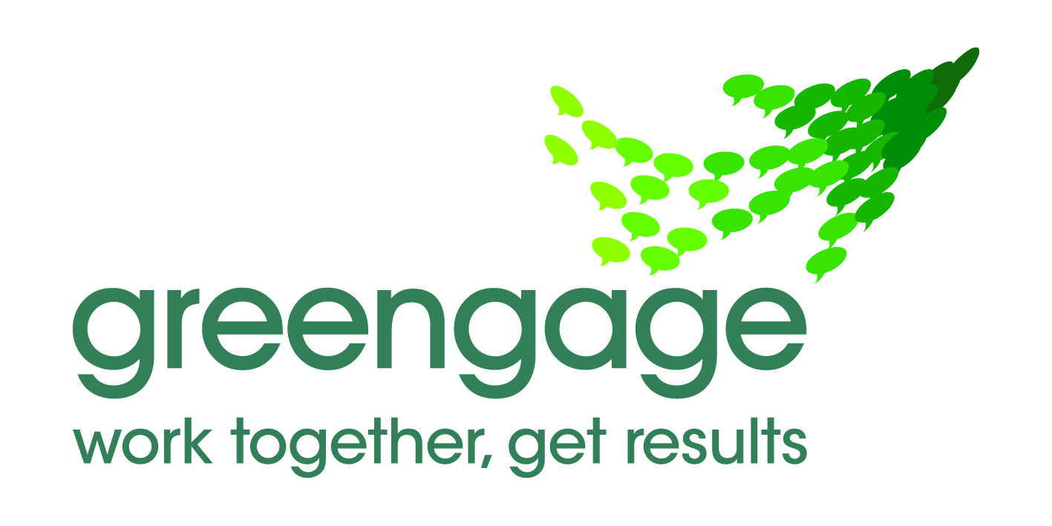

One South Lakeland Partnership Board Planning Meeting

Meeting Report

Introduction

This report summarises discussions during agenda item 4 of the One South Lakeland Board meeting on 14th October 2011. The Board considered;

- The purpose of the Partnership

- Priorities that the Partnership will focus on in the year ahead

- Ways of working that will ensure high levels of performance of the Board and the Partnership

- The purpose of the Partnership

During the discussions the purpose of the Partnership was considered. It was agreed that the Partnership has an important leadership role in South Lakeland;

- identifying and leading on priority issues of importance to local people
- working through organisations, partnerships and forums to focus attention and resources on those priorities
- measuring performance and creating a culture of accountability

- Priorities for action

The Board discussed their views on the issues that partners could focus on in the year ahead. An initial ‘long-list’ of possible priorities was prepared. Members then identified those priorities that the Board must focus on in the year ahead. Comments made are summarised in Tables 1 and 2.

Table 1 Possible priorities for the Partnership

- Engage all elements of the local community. Members of the Board will build the ethos and practice of community engagement and localism in their organisations and in the forums in which they operate e.g. Local Area Partnerships. Local people will feel listened to, will see local service providers as responsive and will feel they are able to influence their future.

- Facilitate more diverse employment opportunities. The Partnership will support more diverse employment opportunities, encourage entrepreneurship and promote the benefits of South Lakeland to potential employers.

- Improve health and well-being opportunities. The Partnership will create opportunities for local people to enjoy healthy life-styles. Emphasis will be placed on prevention of ill-health.

- Deliver homes to meet local need. The Partnership will promote schemes that help satisfy the housing needs of older and younger people.

- Improve transport services. The Partnership will support improved public transport links for visitors and residents.

- Promote practical activities that deliver improved sustainability within Communities. The Partnership will improve awareness of the effects of climate change and will encourage practical initiatives such as local sustainable energy production.

- Reduce crime and anti-social behaviour. The Partnership will promote activities that keep people safe by reducing crime and anti-social behaviour and ensure that local people feel safe.

Table 2 Priorities for action for the Partnership

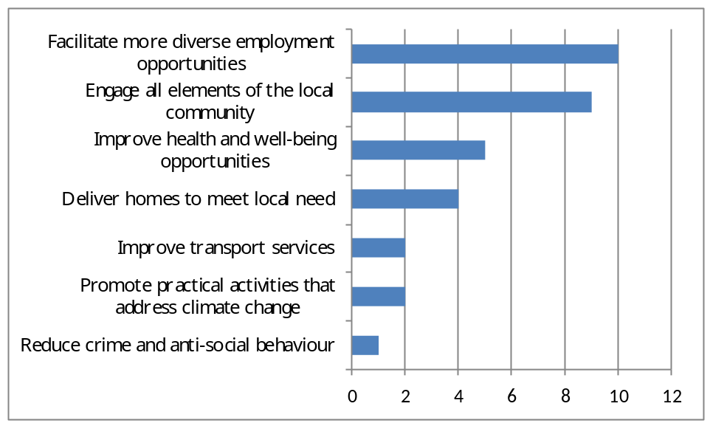

3. Ways of working

Members of the Board discussed ways of working with particular focus on the goals and performance of the Board and the proposed Task and Finish Groups. Recommendations made during the discussions are summarised in Table 3.

Table 3 Proposed ways of working

- Focus the Partnership on a small number of clear, specific and realistic targets that address the needs of local people. Ensure that the Task and Finish Groups have clear goals and action plans.
- Work together to achieve collective commitment to and delivery of the agreed targets for the Partnership. Ensure that members of the Board commit time to feedback into their organisations. Make sure that the Task and Finish Groups operate as highly focussed, multi-agency groups that deliver ‘high-performance’ collaborative working.
- Work effectively with County and District level partnerships including the Local Area Partnerships and the Local Enterprise Partnership.
- Learn from good practice.
- Measure and monitor performance of partners organisations, forums and partnerships
- Communicate superbly internally and external. Regularly communicate progress to South Lakeland communities to achieve buy in from all levels of the community

